Quantum Electrodynamic Effects in Multi-TeV Scale e-e+ Collisions
Ryan Saelens | Dr. Philippe Piot | 05.03.2024

Abstract
Abstract
When we accelerate a high-density beam of electrons (e-) to collide with a high-density beam of positrons (e+), antimatter electrons, many affects arise that disrupt the beams’ travels, and ultimately their collision. When a charged particle accelerates near another charged particle, it can get deflected and slowed down, resulting in less energy for the accelerating particle as it travels in the new direction. The approached particle is guilty of emitting a form of electromagnetic radiation, known as beamstrahlung. Along with this effect, certain quantum electrodynamic effects (QED) need to be considered, regarding the disruption, collision, and production of photons, as well as the production of e-e+ pairs that result from the e-e+ beams colliding. The following effects will be addressed: quantum synchrotron; Breit-Wheeler process (BW); Multiphoton Breit-Wheeler process (MPBW); Bethe-Heitler process (BH); and the Landau-Libshitz process (LL). Note that the QED effects are not something that happens after the collision (not necessarily), but rather, they are conditions that the e-e+ beams undergo as they approach each other, and even more so when they collide. These effects are also known as beam-beam effects. Simulations of e-e+ collisions, both with and without the QED effects they experience, as well as simulations conveying the photon production, and too the e-e+ pair production will be shown through the implementation of Warpx’s particle-in-cell framework [7].

Introduction

Introduction

A proposal has been made for an e-e+ collider—the Advanced LInear
Collider, otherwise known as ALIC, with a theorized center-of-mass (COM) energy of up to 10 TeV. With a machine capable of achieving such high energy levels we are forced to explore and study the physics—that is, the interactions and effects the e-e+ beams experience as well as the creation of potential new particles; and in turn, stronger, more efficient machines can be developed for use in high-energy physics [6]. First, the significance of a linear e-e+ collider will be addressed which will help to better appreciate the potential benefits from a linear collider such as ALIC; this will be followed by how we measure the performance of such a machine, along with visualizations of the challenges that need to be considered, i.e. the QED effects.

Colliding Electrons and Positrons
Colliding Electrons and Positrons

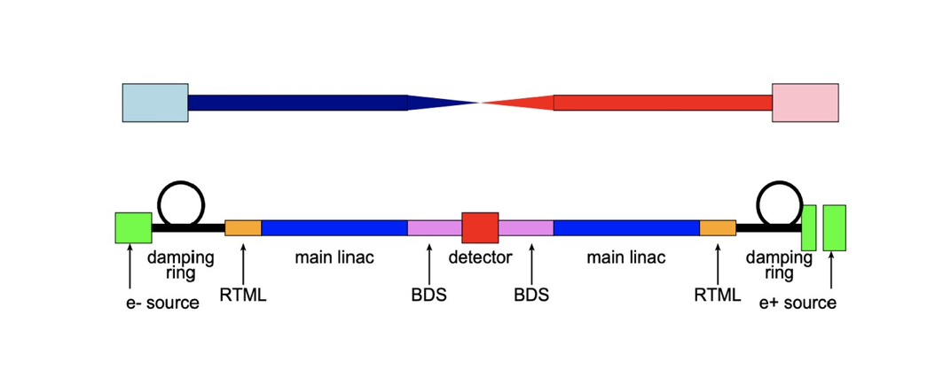

Consider Fig. 1 above of a linear e-e+ collider [5]. What is the significance of using electrons and positrons? And why are we choosing to collide them linearly? Well, electrons, in comparison to hadrons (e.g., a proton, which is composed of smaller, component-particles—quarks, which are held together by even smaller particles—known as gluons), consist of no smaller particles; an electron is fundamental in Nature, and therefore its antimatter counterpart– the position—can also be thought of as being fundamental in Nature. Since they consist of no smaller particles, they can be thought of as point-particles. An interesting property of both electrons (leptons) and positrons (anti-leptons) is that they feel the influence of the fundamental forces, i.e. electromagnetic, gravitational, and weak—yet the strong force seems to have little to no influence over their behavior. This is a result of being point-particles; they have nothing inside for the strong force to glue and hold together (not to mention the strong force relies on gluing neutrons and protons together, neither of which need to be considered here).
When these electrically-charged particles are accelerated to near-lightspeed, and then smashed together, their collision offers a great deal of energy, resulting in the conversion of two high-energy (also called gamma-ray) photons. For a linear e-e+ collider, such as the one in Fig.1 above, it’s important to understand that we are not sending individual electrons to collide with individual positrons. Instead, we are considering the case of accelerating high-density beams of electrons (as indicated by the blue beam in Fig. 1) and positrons (as indicated by the red beam in Fig. 1) to collide whilst studying their behavior and performance along the way. Where the beams “collide” is known as the center-of-mass energy, which can be calculated based on the “brightness” of the machine, i.e. the luminosity; more on this later. I say “collide” because for reasons that will become clearer later on, the beams don’t collide necessarily; for now, just remember that the rate of disruption the e-e+ beams experience, increases as they get closer and closer to each other; this makes it hard for the beams to collide head-on. With that said, a benefit of colliding point-particles, is that the collisions result in far less noise than that of colliding hadrons; something we should consider as we continue our search for particles of rarity, such as a Higgs boson, or something even more controversial like a dark matter particle [1].
Since we now understand why we are colliding high-density e-e+ beams, instead of individual particles, it will now be addressed why we opt to use a linear collider as opposed to a circular collider, such as that of CERN’s Large Hadron Collider (LHC). This is simply so we can achieve the formation of a beam; it proves to be much more of a challenge to create high-density beams of charged particles whilst being accelerated in a continuous, circular fashion. Both beams have to travel quite far, with machinery set in place to hold the structures of the beams tightly together, ending with each beam being accelerated through their own Beam Delivery System (BDS) which has the purpose of focusing the beams to a certain precision before reaching the detector, which is placed at the point of collision [5].
Remembering that both electron and positron beams consist of charged particles, we must understand that each electron not only has an influence on the neighboring electrons that share the same beam, but also, each electron can and does contribute to the overall effects that are cast onto the opposing beam of positrons. The same can be said about positrons: each positron in the beam, effects the other neighboring positrons, as well as the beam of incoming electrons. Why these effects arise in the first place will be explained soon enough.

The Advanced LInear Collider: ALIC

A linear e-e+ collider with a COM energy of 10TeV would be a marvel for physics in general, for high-energy and particle physics specifically. But why exactly? What benefits can we expect to obtain from a machine such as ALIC? Well, as highlighted above, we will be at the very least, forced to study any effects that our charged particle beams may experience, which can lead to potentially new interactions of interest. We can also expect to measure known particles that the Standard Model (SM) is comprised of, with greater precision; a result of dealing with such high energies. So, the more energy we have, the more confidently we can probe known particles to see if they will showcase any properties that may have remained hidden whist being measured at lower energies, i.e., energies below the multi-TeV range. Another benefit of using point-particles, which as a reminder, do not contain anything on their insides, is that we can better study their interactions at extremely short distances. This is addressed in [1] along with the idea that we need to consider e-e+ colliders with COM energies measuring in the multi-TeV range and above—that is—if we wish to discover new leptons (and anti-leptons of course), as well as any potentially new interactions that may not be observable at lower energies.

Measuring Performance: Luminosity

As the e-e+ beams collide (but also as they accelerate), they emit photons that we observe as a “brightness” coming from the middle of the machine—what is usually thought of as a big, bright ball of energy. This is a result of e-e+ collisions, and the COM energy of the collider is of particular interest. This bright light can also be referred to as the luminosity: a measurement of the rate of production over time, with a given cross-section sigma. The luminosity can be expressed mathematically as follows:

$$\frac{dN}{dt}=L*σ$$

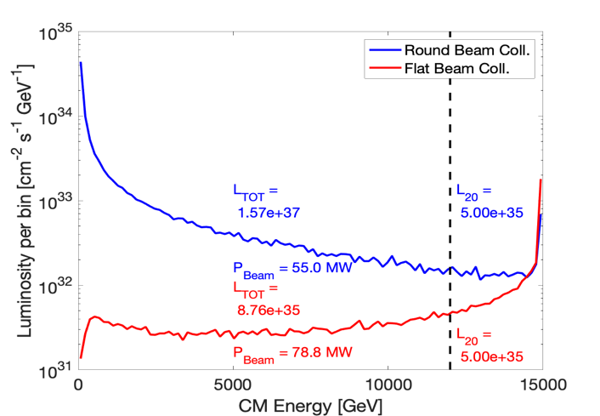
The cross-section sigma is a value relating to the probability of events occurring (i.e. collisions), so logically speaking then, if we are dealing with acceptable values for the cross-sections of our e-e+ beams, i.e., a high probability of collisions taking place, we should then be able to assume that a value of luminosity will be produced, to then be measured and compared against whatever the expected goal value may be. The luminosity depends on the parameters of the beams being accelerated as shown in Fig. 2, below [7]. We can see that different measurements for luminosity are obtained as a result of accelerating and colliding flat-beams (red) vs the case of colliding round-beams (blue): the former shows an increase in luminosity as energy increases, while the latter shows a decrease in luminosity as energy increases. This is because for the case of round-beams, the cross-section decreases as energy increases, therefore effecting the value of luminosity.

Beam-Beam Effects
What follows will be a list of the QED effects that both beams of electrons and positrons will experience: some of the effects (processes) will manifest early, disrupting the beams while they travel towards one another; other effects don’t become present until the beams approach each other quite closely—this disruption on the beams happens to be much more noticeable. Note that each one of the QED effects listed, except for synchrotron radiation, results in the production of an e-e+ pair. For those effects in particular, a Feynman Diagram [3] has been provided alongside each explanation as a sort of visual aid.

Synchrotron Radiation: Beamstrahlung
An accelerating charged particle feels a form of electromagnetic radiation that is being emitted from another charged particle as it passes by. This charged particle in motion can be slowed down and deflected, due to this radiation–known as beamstrahlung—a form of synchrotron radiation. Think of it as a sort of particle-fatigue. From this we can better understand what was stated before regarding why each electron in the electron beam will exert a force on itself as well as on each positron in the positron beam; it similarly explains why the positrons will exert a force on themselves, and also on the electrons. Synchrotron radiation can also be due to electrons and positrons accelerating quickly through an external magnetic field which can lead to the emission of discrete high-energy photons [1].

Linear Breit-Wheeler process

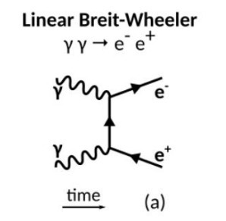
An effect known as the linear Breit-Wheeler process (LBW) explains how two high-energy photons annihilate, resulting in the creation of an e-e+ pair. Seeing how we have many electrons and positrons that our beams are comprised of, and we are aware that discrete photons can be emitted from each electron and/or positron as they accelerate through an external magnetic field, but also that photons can be created as a result of colliding electrons with positrons, we have an extremely high probability (intuitively speaking) of e-e+ pairs being produced.

Multiphoton (Non-Linear) Breit-Wheeler

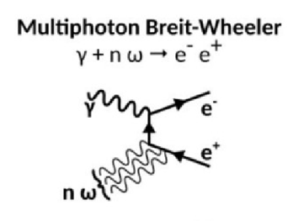
An effect known as the Nonlinear Breit-Wheeler process (NLBW), also known as the Multiphoton Breit-Wheeler process, occurs when an individual high-energy photon accelerates through an external magnetic field, and much like the LBW process, results in the emittance of an e-e+ pair [2]. This effect can be due to synchrotron radiation—the photon that emits the e-e+ pair comes from an electron or positron in the beams as they themselves accelerate through an external magnetic field. A photon that experiences this effect can also be a photon that is again, a result of successfully colliding an electron with a positron. The main difference between the nonlinear and linear Breit-Wheeler processes is the substitution of a high-energy photon for an external magnetic field; both lead to e-e+ pair-production.
Bethe-Heitler
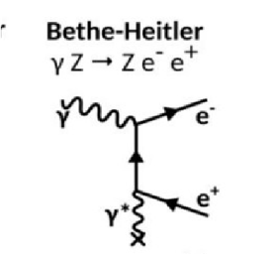
There is another QED process that deals with the emittance of an e-e+ pair from an individual high-energy photon; this process is called the Bethe-Heitler process. It states that a high-energy photon emits an e-e+ pair while accelerating by another, individual particle—this particle however is a charged particle and not another photon. So, a high-energy photon passing by an electron (which has a negative charge) can experience this effect, and insomuch is true regarding the case of a high-energy photon as it passes by a positron (which has a positive charge). The Bethe-Heitler process therefore doesn’t seem to pay much attention to the type of charge a particle has, negative or positive—it doesn’t matter—only that the photon passes by a particle with charge.

Landau Lifschitz
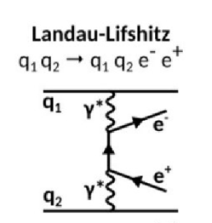
There is another QED effects that closely resembles that of the Bethe-Heitler process. This effect is called the Landau-Lifshitz process. Where the Bethe-Heitler process deals with a high-energy photon passing by a charged particle to produce an e-e+ pair, the Landau-Lifschitz process states that a charged particle can also emit an e-e+ pair as it accelerates past another charged particle. Essentially, a charged particle effects another charged particle, and this ends with the production of an e-e+ pair. So, this would mean then that each of the electrons in the electron beam have the potential to affect not only those around them, but also the positrons in the positron beam; and as stated before, the same is true the other way around. Therefore, we can expect many e-e+ pairs to be produced as a result of the Landau-Lifschitz process. Note that this QED effect cannot yet be simulated using WarpX.
Simulating Beam-Beam Effects Using WarpX
So, what do these beam-beam effects look like? How can we visualize them? Well, as of March 2024, WarpX, a program in development, used to simulate e-e+ collisions, is currently capable of simulating the effects of both quantum synchrotron as well as the non-linear Breit-Wheeler process—the other QED effects are to be implemented over the following few months [2]. Presented below are multiple still-shots of simulations of 2D flat-beams using WarpX’s particle-in-cell framework [7]. There will be two groups of photos presented: the first group pertains to what an e-e+ collision would look like if we need not consider any such QED effects; and the second group, pertaining to a more realistic scenario—a world where QED effects must be considered. The difference should be quite noticeable. Note that the electron beam is yellow, and the positron beam is blue.
Without QED Effects

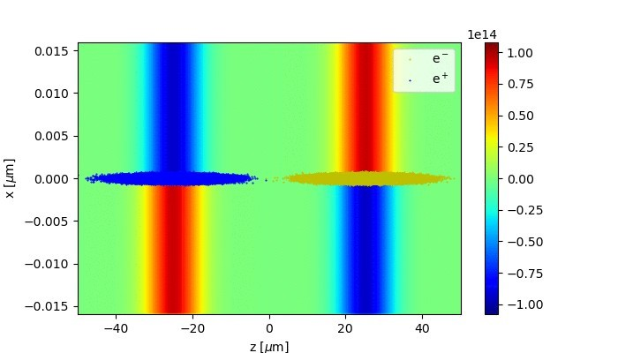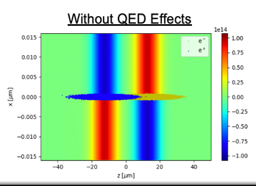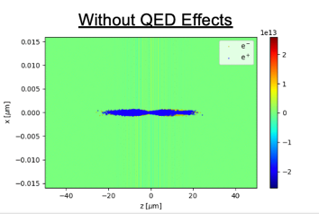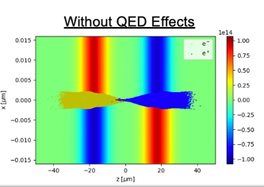
Granted, the images are small, however, having them in sequence such as how they are above makes it easier to visualize and (hopefully) understand how the beams interact as they approach, and eventually pass each other. What we can surmise from this grouping of images is this: the particle beams start of a distance away from each other in the first image; they continue to accelerate over the course of the next two images, and end with the beams passing smoothly by each other in the last image. Next, we shall consider a grouping of images much the same as those above, only now with the consideration of the QED effects.
With QED Effects
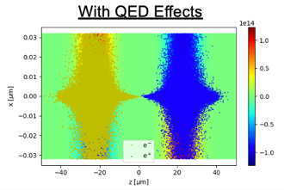
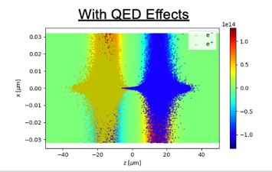
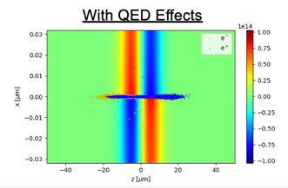
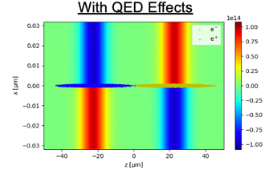

Again, the images may be small, but what we need to focus on, albeit, what is most important to understand here, is the distribution of particles as the beams collide. Starting with the leftmost image, we have our accelerating beams; the next image to the right, conveys the beams essentially colliding—they appear to be overlapping one another. This is where they become subject to the QED effects listed above, which results in a large scattering after interacting; this scattering is nicely portrayed in the remaining two images to the right. It’s important to remember that we have multiple QED effects that result in the production of both high-energy photons, and e-e+ pairs. Therefore, the scattering that we see in the two far-right images, conveys the distribution of both high-energy photon production, as well as e-e+ pair production.

Further Considerations: e-e+ collider at 10TeV and above
We need to already be thinking about the possible benefits that can be obtained through the implementation of accelerators (colliders) with COM energies of at least 10TeV. Let us go back to the dark matter particle problem for a moment. Since the dark matter particle is composed of no ordinary matter, it weakly couples to known matter. It is proposed in [1] that the dark matter particle manifests as a light particle (form of photon) and doesn’t get detected due to its composition and interaction(s) with ordinary matter. This seems like a problem relating to the QED process of quantum synchrotron, specifically speaking, it can happen as a result of each charged beam as they get sent through their own Beam Delivery System (BDS), which is a hardware component that has the purpose of refocusing the beams to a certain precision, and usually they are set up right before the point of collision.
WarpX can address and simulate this QED process, which can lead to the ruling-out of certain discrete photons being possible dark matter particle candidates. Interestingly enough, this problem of electroweak symmetry breaking, along with the spectrum of fermion masses, and the CP violations[A1] , can really only be explained by short-distance interactions such as those interactions made by electrons and positrons [1].
The Advanced Linear International Collider (ALIC) is proposed to be built by 2040. In reality, this is not very far away. During this time, due to the implementation of ANAs to advance collider technology, we can look forward to seeing advancements in the fields of biology and medicine [6] while we wait for advancements in high-energy physics. This makes sense intuitively due to the important use of electrons in both fields. With that said it is a lepton collider [1] that must be relied on in order to explore the full range of particles that sit within the region of 10 TeV and above. From searching for particles, we can then move on to confronting the deeper issues of the universe.
Conclusion
By now we should have a better understanding of what a linear e-e+ collider is, and what significance it holds with respect to the fields of high-energy and particle physics. The Advanced LInear Collider (ALIC) is (for now) a theoretical linear e-e+ collider with a proposed COM energy of 10 TeV, which will force us to study the interactions of point-particles as well as any effects they undergo, with even the possibility of observing (measuring) new particles as a result of obtaining such a high energy output. Recall that the performance of the machine can be measured based on the luminosity but this value will be different depending on if the beams are flat-beams or round-beams, for example. WarpX can already deliver precise, and accurate simulations of e-e+ collisions, therefore it seems rather reasonable to assume that WarpX will be capable of simulating the full list of QED effects above, implemented by the time ALIC is ready to operate—in fact ALIC seems almost reliant on WarpX being able to properly simulate the QED effects that e-e+ beams experience as they collide with extremely high-energy output. It can also be the case that by creating ALIC we can then run simulations using WarpX at the new COM energy output, which can in turn help us better understand the certain properties that affect our e-e+ beams.

References
[1] ALEGRO Collaboration. Towards an Advanced Linear International Collider. (2019). https://arxiv.org/pdf/1901.10370.pdf
[2] R. Lehe, J.L. Vay. Plans for WarpX. (2024).
https://indico.slac.stanford.edu/event/8597/contributions/8188/attachments/3935/10601/2024_beam_beam.pdf
[3] A. Formenti. First results of beam-beam simulations with WarpX. (2024).
https://indico.slac.stanford.edu/event/8597/contributions/8191/attachments/3936/10602/beambeammeetingslac.pdf
[4] W. Herr, T. Pieloni. Beam-Beam Effects. (2014). https://cds.cern.ch/record/1982430/files/431459%20Herr.pdf
[5] D. Schulte. Beam-Beam Effects in Linear Colliders. (2017).
https://indico.cern.ch/event/457349/attachments/1175828/1699810/Beam-beam2.pdf

[6] B. Cros, P. Muggli. ALEGRO input for the 2020 update of the European Strategy for Particle
Physics: comprehensive overview. (2020).
https://indico.cern.ch/event/765096/contributions/3295514/attachments/1785110/2906015/2018ALEGRO_ESPP.pdf
[7] S. Gessner. SLAC. Beam-Beam Meeting at SLAC. (2024). https://docs.google.com/presentation/d/120J9lWAcpK4Hsj0jktCw61iZGLTTqrtuUPDaGtZRvE8/edit#slide=id.p1

